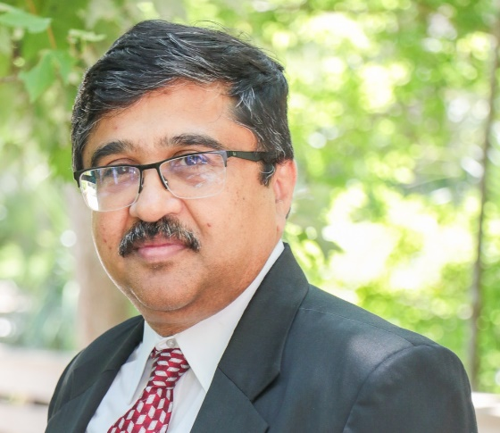
Dr. Jay Kapat is Pegasus Professor and Trustee Chair in the Department of Mechanical and Aerospace Engineering in the University of Central Florida, and is the founding director of the Center for Advanced Turbomachinery and Energy Research. He obtained his Sc.D. in mechanical engineering from Massachusetts Institute of Technology. He joined UCF in 1997 as an assistant professor, and was promoted to the ranks of associate professor and professor in 2001 and 2005, respectively. Since the mid-2000s, Dr. Kapat has fully focused his research activities on turbo-machineries and associated technologies for power generation, aviation and space propulsion, and created partnerships with a number of OEMs in these industries.
“Research at CATER on Sustainable Energy Systems”
Florida has a large conglomeration of power generation and related companies. US headquarter of Siemens Energy and Americas headquarter of Mitsubishi Power are both located in Orlando. US headquarters of both Hanwha / Power Systems Manufacturing and Doosan are also located in Florida. Raytheon / Pratt & Whitney and Aerojet Rocketdyne also have large engineering operations related to turbine engines in Florida. In order to “serve” all these OEM’s, and many of their suppliers and support companies, the Center for Advanced Turbomachinery & Energy Research (CATER) was started at UCF in 2012. CATER currently has 11 tenured or tenure-track faculty, 12 research faculty or postdoctoral research staff and more than 150 research students.
There are 6 current, active initiatives at CATER, in response to mega trends in related fields that are also synergistic with needs for Florida companies. Two of these initiatives are on low carbon technologies and supercritical carbon dioxide (sCO2) power cycles, which are directly related to sustainable energy systems. sCO2 systems, based on Brayton cycle or on variations of it, are quite versatile in applications. sCO2 cycles can be operated in closed loop, where heat from concentrated solar receivers or from nuclear plants or waste heat from cement or steel plants can be converted to electricity. The semi-closed or direct-fired version of sCO2 systems can use oxy-combustion of natural gas with automatic carbon capture.
Under low carbon technologies, various uses or storage of hydrogen and/or ammonia are being investigated. In one of the recently awarded NASA projects, CATER researchers and their collaborators from around the nation will look into use of ammonia as a hydrogen carrier for zero emission aviation. The target application is commercial flight. Ammonia stored onboard at -33C will not require any special refrigeration or cryo-cooling at cruising altitude, and will also be used to enhance core performance by providing compressor intercooling and cooled cooling air for turbines. Hydrogen is derived from ammonia through catalytic decomposition to help in thermal management, leading to significantly improved engine efficiency. A fraction of onboard ammonia is also used to eliminate NOx from the exhaust stream. A closed-loop sCO2 power system is used to produce electricity from engine exhaust heat for onboard use and to eliminate power extraction from the core. Hydrogen combustion leads to the absence of soot in exhaust, greatly reducing contrail formation. The proposed technology nearly eliminates every form of emission.

